Accomplished activities last week April 11 Saturday.
Week 1 Activity 1 – Setting up the environment:
I have installed the following applications during our activity.
I have uninstalled Anaconda because it’s a huge file and eating up space. This is all from my old laptop with specification.
I also setup the Github repository in the old laptop.
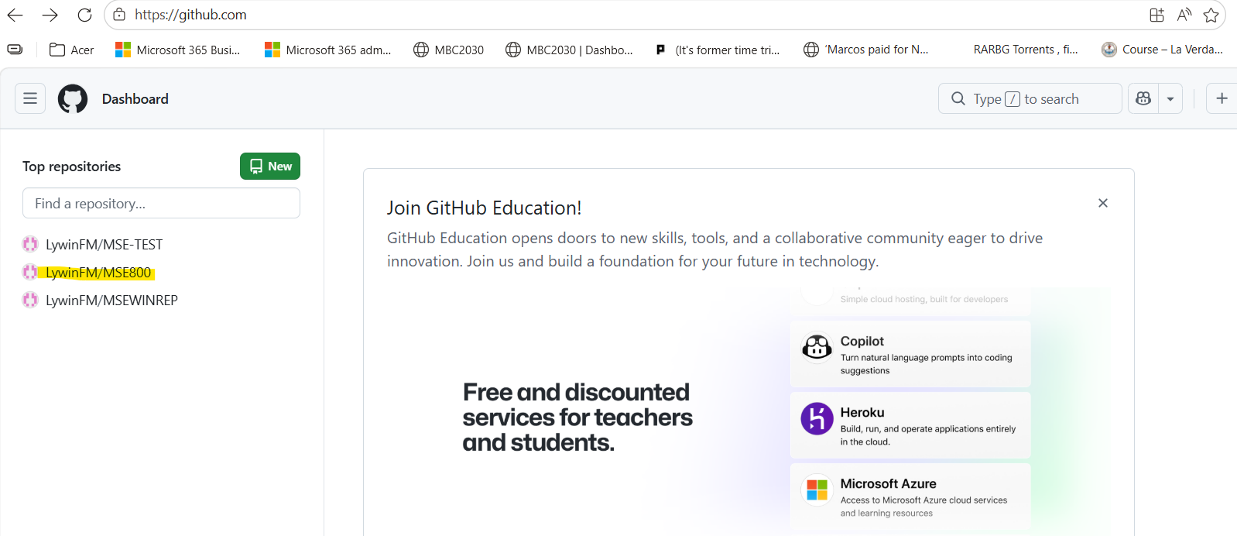
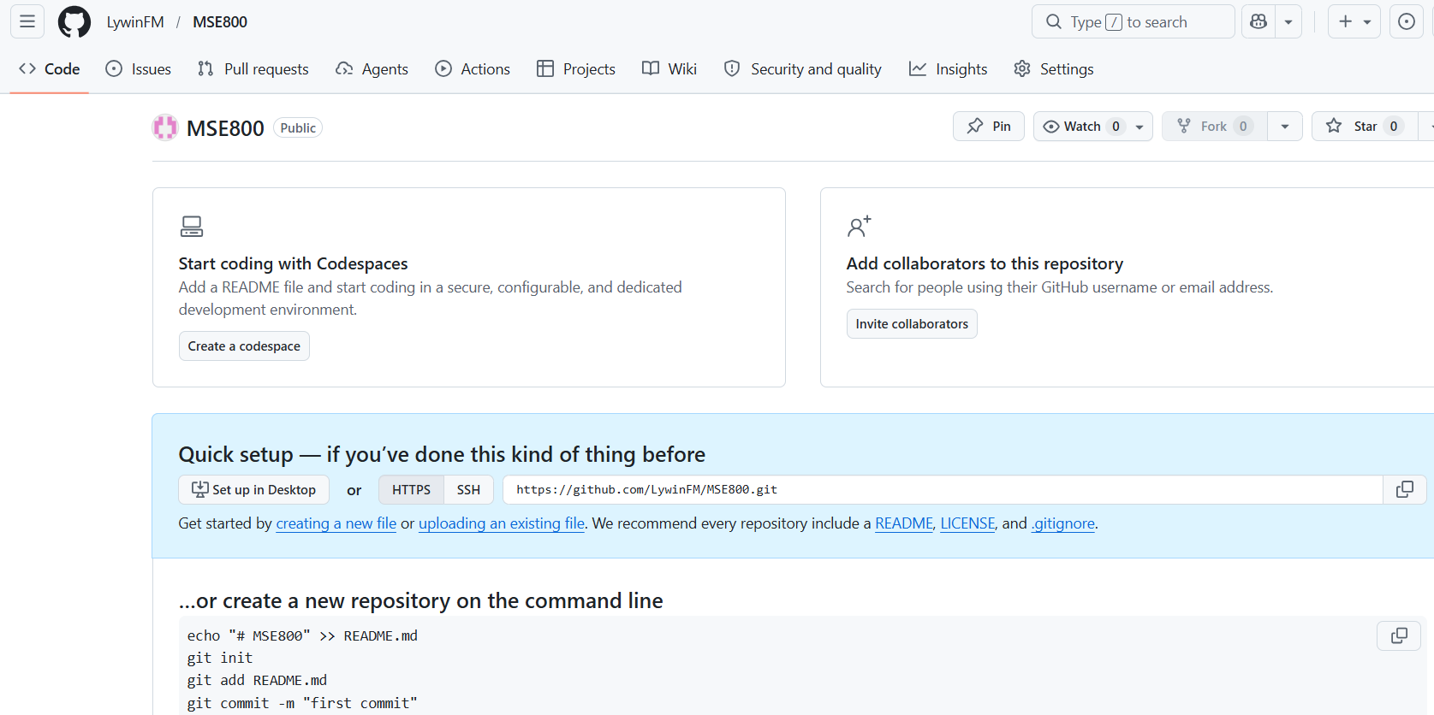
Just letting you know I am performing the activity but I had laptop issue while we are on MS Teams session

